Gizmoball: Weekly Progress Document (Week 5)

CS308 Group MW1

**New issues:**

* Communication between group members
* Final Design: Will we have to go back to it for the final deliverable? (add/remove methods)
* Validation Testing Strategy: is the format correct? Good starting point?

Input, this happens, expected output. Every use case, every alternative path. Go back to Murray’s use case, alternative path (include use cases based on Murray’s feedback)

* How is the marking split up for next week’s deliverable?
* Class Diagram:
  + Are attributes needed for every class apart from the key methods (is that what is meant by data)?
* How does the JUnit Testing Strategy differ from the VTS?

How are we going to use JUnit for our testing

* Use MVC split for class diagram?

Yes, make relationships clear

**Ongoing issues:**

* Redraw class diagram (DTP)
* Update class descriptions document with classes changed, start adding key methods and data (TM)
* Continue implementation of Absorber class for main project and prototype (CR)
* Continue implementation of Flipper classes for main project (TM)
* Continue implementation of Bumper classes for main project and PT2 (DTP)
* Start JUnit Testing Strategy (TS)

**Resolved issues:**

* Use cases updated based off feedback from Preliminary design submission
* All issues from last week
* Start writing Validation Testing Strategy (TS)
* Update Project Plan (DTP)

**Goals for upcoming week:**

* Complete most implementation for prototypes by Monday
* Continue and complete class specifications and class diagram (including explanations)
* Continue and complete Validation Testing Strategy
* Start and complete JUnit Testing Strategy
* Submit Preliminary Release

**Git repository history:**

* Commits from today on the several branches:
  + David branch:

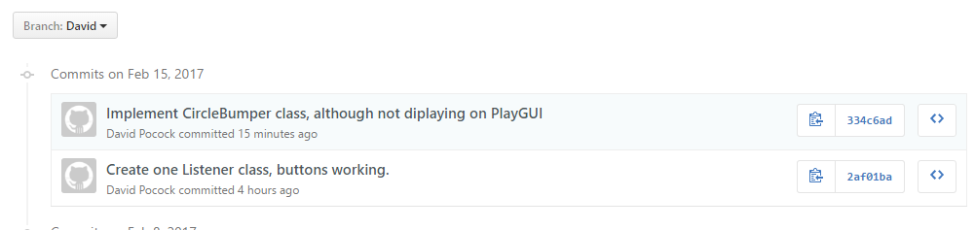

* Greig branch:

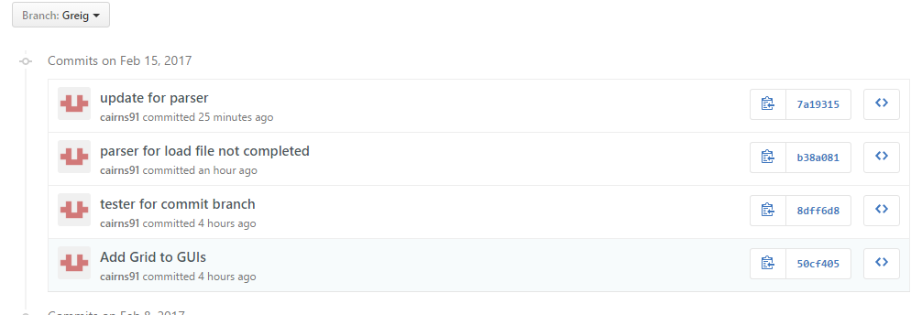

* Chris branch:

